CSC-20024: vIRTUAL wORLDS

Formula 1 Car Model and Animation Project

Student Name: Alex Farrell

Student Number: 15005594

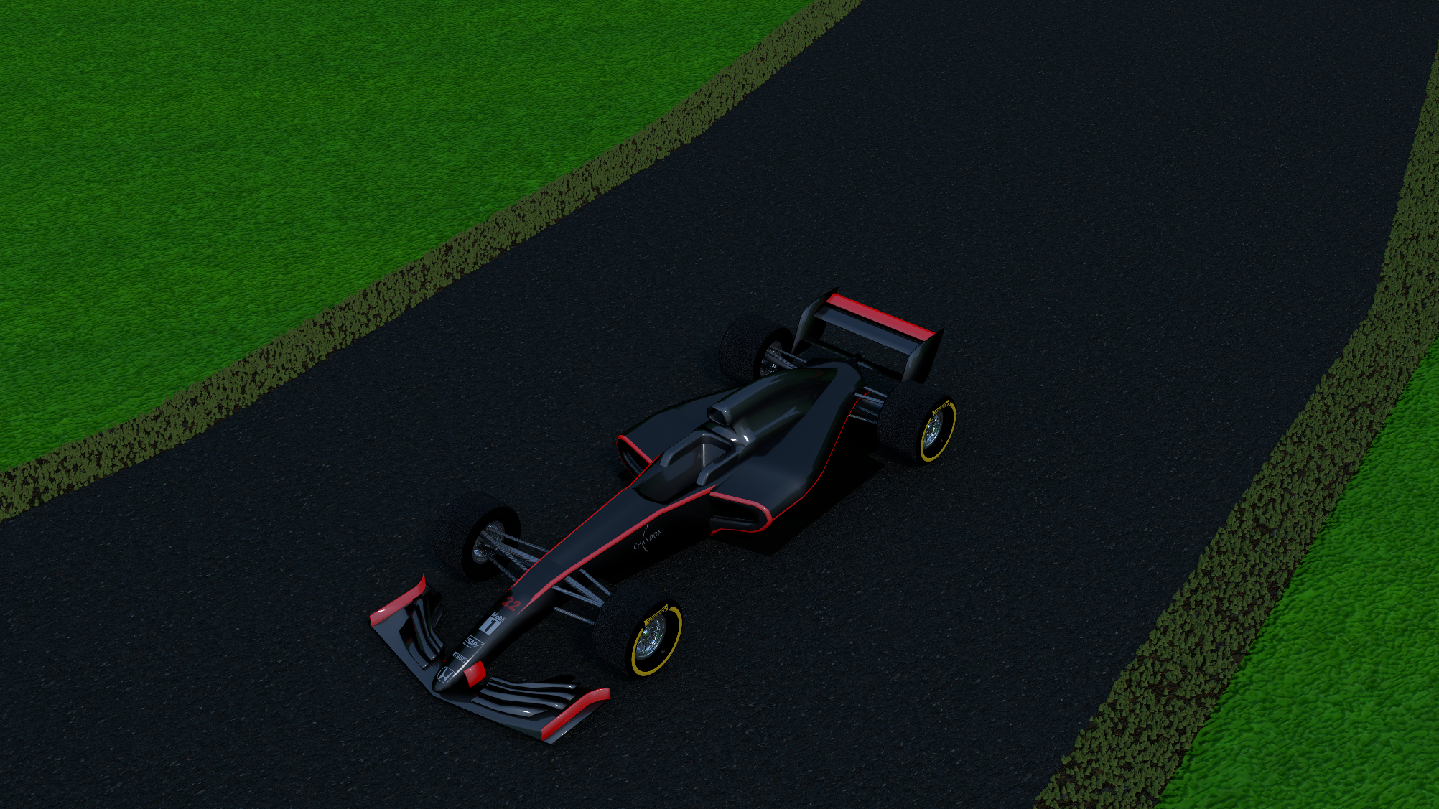

**Contents**

Overall Design 2

Front Wing 2

Nose Cone 2

Wheels 2

Suspension 3

Chassis 3

Rear Wing 3

Grass 3

Track 3

Landscape 3

# **Overall Design**

To ensure than the model was symmetrical, I used a mirror modifier on all parts.

# **Front Wing**

The construction of the front wing began with using the knife tool on a plane to carve out (one half) where the various aero parts where from a birds-eye view. Then, using a side elevation image as a template, I extruded the various parts to the desired size. I then applied materials and texture to the resulting object to create a glossy finish.

# **Nose Cone**

The construction of the nose cone began by scaling a cube to the desired size, then using the knife tool (using cut through) to get the desired shape from a side perspective. The I switched to a birds-eye view to shape the curves at the tip. Once the basic modelling was complete, I used a bevel tool on the back half to create a smooth transition from the top, to the side of the model. Once this was done, I applied materials and textures as well as a custom decal on the front.

# **Wheels**

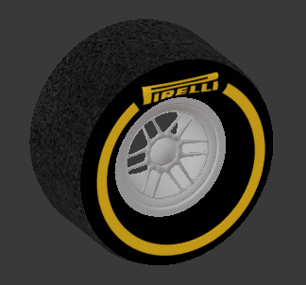The construction of the tyres began with scaling a torus to the desired depth to create the tyre. I then used another cylinder inside to create the rim. I used the knife tool to carve out a 1/6 portion. I then used the duplicate and rotation tool to create a complete rim. I then applied materials and textures, using a custom decal for the front of the tyre, and a bump map for the tyre tread to create the impression of tyre wear.

# **Suspension**

The suspension construction began with a cylinder that was reshaped to create the brake drums. The suspension arms were created by extruding edges from parts of the brake drums, and the extruding them to the desired thickness. I then applied a carbon fibre effect texture over the whole object.

# **Chassis**

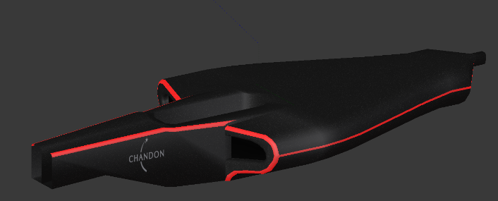The chassis was constructed by reshaping a cube around a bird-eye elevation image, then a front elevation image to shape the side pods. I used a bevel tool to smooth and sharp edges. I then applied materials and textures to give a glossy finish as well as a decal on the sides.

# **Rear Wing**

The rear wing construction began with using a knife tool on a plane to shape the end plates. The bars across the middle were created by using the knife tool to shape the rough curvature. I then applied materials and textures to give a glossy finish.

# **Grass**

To create the grass around the edge of the track, I used a hair particle system, resizing the strands to give the effect of short grass. I then applied a green texture to the grass, as well as a dirt texture using the UV mapping tool, to the base.

# **Track**

The track was created by shaping a Bezier curve around a diagram of the Monza race circuit. I then applied an array modifier and a curve modifier to shape the track around the curve. I then applied a tarmac texture using the bump and mapping nodes to create a realistic tarmac look.

# **Landscape**

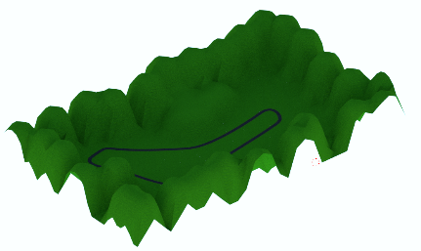The landscape began by subdividing a plane and then carefully selecting vertices around the track area and using the grab tool with sphere falloff to raise them up to create hills. I then applied a grass texture using a mapping tool to create a realistic illusion of grass.

# **Image and Textures – References**

* Chandon

https://r.lvmh-static.com/uploads/2014/10/chandon_logo.png

* Honda

http://www.iconsdb.com/icons/preview/black/honda-xxl.png

* SAP

https://maxcdn.icons8.com/Share/icon/win10/Logos//sap1600.png

* Pirelli

https://upload.wikimedia.org/wikipedia/commons/thumb/e/e4/Pirelli_logo.svg/2000px-Pirelli_logo.svg.png

* Mobil 1

https://www.motorsticker.com/images/products/2179/2179%20Mobil%201.png

* Carbon Fibre

http://cdn.designbeep.com/wp-content/uploads/2012/01/14.free-carbon-fiber-textures.jpg

* Track

http://1.bp.blogspot.com/-4hYFyG-olaU/VNHtJI5KhTI/AAAAAAAAG0w/i0F8m2Yb9ss/s1600/Asphalt%2Broad%2Bwet%2Bseamless%2Btexture%2B2048x2048.jpg

* Grass Landscape

http://textures101.com/textures/Nature/Grass/2012/1/15/tn1_4182507849028a2df3c2o_kkwbe.jpg

* Dirt

https://www.filterforge.com/filters/10838-v1.jpg